Performance Analysis of Scheduling Algorithms with Delayed Channel Feedback in Multi-cell OFDMA Networks

Author: Jinghong,Yang
Supervisor: Gabor Fodor, Ericsson Research
Ben Slimane, Royal Institute of Technology (KTH)
Examiner: Ben Slimane, Royal Institute of Technology (KTH)

Abstract

In this thesis, we use system level simulations to gain insight into and quantify the influence of channel state information feedback delay in a multi-cell OFDMA system, and focus is put in uplink. We analyzed the interplay between scheduling, power control in a multi-cell environment when the channel state information is subject to feedback delay.

We found that reducing Channel State Information (CSI) variation can reduce CSI estimation errors due to feedback delay, which is beneficial in the sense of increasing system throughput and coverage. Among the four schedulers we studied (Round Robin (RR), Proportional Fair in Frequency domain (PFF), Proportional Fair in Time and Frequency domain (PFTF) and persistent scheduler), PFF scheduler gives best system performance. To improve the performance of PFTF, persistent scheduling and bandwidth dependent power control are recommended. Persistent PFTF scheduling can increase 12% cell throughput compared to pure PFTF. When combined with bandwidth dependent power control, PFTF can increase 33%-46% respective to different cell load.

Acknowledgement

I want to show my thanks to Ericsson Research for providing me this opportunity to conduct my thesis in a real industrial environment. It’s a challenging as well as rewarding experience. I have to show my gratitude to many people.

First I want to show my tremendous thanks to my supervisor in Ericsson Gabor Fordor. Thanks for picking such an interesting topic for me; thanks for sharing your knowledge and wisdom without any conservation; thanks for showing great patience and confidence on me. Thanks very much for your great help through these months! I’d also like to thank Per, Chrysostomos, Aram, Muhammad and Anders, for their opinions and comments on my work. Besides, I’d also like to express my thanks to my manager Magnus Persson for his administrative help all the time. It’s a great experience working in Ericsson Research with experts specialized in different fields and everyone is ready to help. Thank you all!

I’d also like to thank Pro.Ben Slimane, my supervisor and examiner in KTH, who gave me valuable comments and support. And all the master thesis students, thanks for providing me such a joyful working environment, miss you all.

This work has been partially supported by the European research project COOPCOM.

Thanks.

Contents
1. Introduction 1
1.1 Background 1
1.2 Previous Work 2
1.3 Problem Statement 2
2. System model 5
2.1 System Overview 5
2.2 Channel model 7
2.3 Time-frequency structure 9
2.4 Channel State Information Metric 10
2.5 Scheduling 10
2.6 Power control 12
2.7 Link Adaptation 15
3. Scheduler and Power Control Performance in Single Cell Systems 19
3.1 Simulation Environment 19
3.2 System Performance with Fixed Output Power 21
3.3 System Performance with Bandwidth Dependent Power Control 26
3.4 System Performance with Non-ideal Link Adaptation 32
3.5 Conclusions of the Single Cell Study 34
4. Scheduler and Power Control Performance in a Multi Cell System 37
4.1 Causes of Inter-cell Interference Variation 37
4.2 Proposed Solutions 38
4.3 Simulation Results and Analysis 39
4.3.1 System Performance with Fixed Output Power Allocation 39
4.3.2 System Performance with Bandwidth Dependent Power Control 42
4.3.3 System Performance with Higher User Speed 44
5. Conclusions and Future Work 47
5.1 Conclusions 47
5.2 Future Works 48
Reference: 49

1. Introduction

1.1 Background
Orthogonal frequency division multiple access (OFDMA) is a promising technology that is currently being standardized for various wireless access networks, notably for the long term evolution (LTE) of 3G networks [1]. In OFDMA networks, radio resource management (RRM) techniques are used to maximize system throughput as well as to provide appropriate quality of service (QoS) for end users. To this end, dynamic packet assignment (scheduling), power control, and link adaptation (LA) and the interplay between these functions play an important role.

In broad terms, scheduling is responsible for assigning time-frequency resources to a certain (group of) users. Transmission power control is used to improve system throughput (e.g. water filling) and to maintain fairness by helping cell edge users reach a certain signal-to-interference-and-noise (SINR) target. Link adaptation (LA) employs channel adaptive modulation and coding rate to increase the achievable data rate (spectrum efficiency) according to the channel conditions. In systems employing multiple antennas, antenna group selection and dynamic (multi-mode) pre-coding, including the adaptation of the transmission streams provide examples of adaptive resource management techniques [2].

In order for dynamic and adaptive RRM functions to work, obtaining channel state information (CSI) is crucial, because it is the basic input to these functions. Unfortunately, wireless channel characteristics vary rapidly in time - often at the time scale of milliseconds - which makes the application of adaptive radio resource management techniques non-trivial. In particular, wireless channel measurements typically suffer from delays and errors, both in the time and the frequency domains, which pose a challenge specifically on CSI estimation.

More specifically, precise and instantaneous CSI is not available due to:

- Resource limitation: In order to save resources, only a limited time-frequency resources can be used for CSI measurements and reporting between mobile stations and radio base stations.
- Measurement errors: equipment imprecision, quantization noise.
- Feedback delay: the CSI estimation based on prior measurements can only be used for subsequent data transmissions. In practical systems, protocol aspects and resource limitations introduce a feedback delay that is typically a multiple of the time unit used for scheduling, power control and link adaptation decisions.

The first aspect has been pointed out by [2]that provided an overview of recent works on limited feedback communications. The second problem is discussed in, for instance, [3]and the references therein.

While all three aspects have been extensively studied in isolation, the joint system level impact of the above three factors, especially in multi-cell systems, is less understood and analyzed when employing realistic scheduler, power allocation and mobility models.

Therefore, the purpose of this thesis is to develop a system level model that is applicable to study the usefulness of link adaptation in a multi-cell OFDM system in the presence of CSI delay. Thereby, our purpose is to gain insight into the practical applicability and to verify the performance gains of dynamic adaptive modulation and coding schemes in realistic, multi-cell OFDM systems. While we take into account the first two aspects above, our focus is on the impact of the CSI feedback delay, because it appears to be particularly important and yet little understood area.

1.2 Previous Work
In [2]and [4], a 4ms delay of CSI is modeled in the downlink of an OFDMA system. Simulation results show that the system throughput and coverage are degraded in the presence of CSI delay.

In [5], the authors study the problem of inter-cell interference fluctuation and propose two resource allocation schemes to mitigate its variation:
- User grouping: radio resource is limited to be allocated within a group of users generating similar inter-cell interference.
- Power compensation: inter-cell interference fluctuation is compensated by adjusting transmission power of the user

In [6], the authors propose a low interference variation scheduler in the sense that each time the base station schedules more or less the same amount of resource blocks. Combined with inter-cell coordination, each cell produces a relatively stable interference to other cells.

In [7], the authors analyze the impact of SINR feedback delay on the link adaptation performance and further the system throughput in the uplink of OFDM cellular systems.

1.3 Problem Statement
In multi-cell OFDMA systems, the inter-cell interference variation is dependent on the behavior of neighboring cells and it is often hard to predict without inter-cell coordination. However, inter-cell coordination is resource consuming and can operate on a relatively long time scale in real systems. Thus, we rely on distributed resource allocation algorithms to mitigate interference variation. That is, when applying resource management, while trying to optimize performance of own cell, we also make consideration of the interference the scheduled user may cause to other cells. Our ultimate goal is to improve the performance of the multi-cell system as a whole.

In this thesis, we study the impact of different scheduling and power control schemes on system performance when the CSI estimation is subject to feedback delay. Proportional fair in frequency domain scheduler and bandwidth dependent power control are proposed for uplink OFDM transmissions. These two resource allocation schemes exhibit improved system throughput and coverage compared to traditional scheduler like round robin and fixed output power, especially in low speed scenarios.

The contents of the thesis are organized as follows:

In Chapter 2, the system model and the relevant radio resource management functions are introduced. In Chapter 3, we compare the performance of several schedulers and study the effectiveness of power control in a single cell system. In Chapter 4, we extend our study to multi-cell system and the main results are reported. Finally, in Chapter 5, conclusions are drawn and future works are suggested.

2. System model

2.1 System Overview
In this study, we consider the uplink OFDM multi-user multi-cell system. And we confine our study within single input single output (SISO) scenario. In each cell, a number of users can transmit simultaneously. Due to the existence of interference, channel reciprocity cannot be reliably used regardless of duplex schemes. The base station is responsible for resource allocation. Firstly, it has to be informed of the user channel conditions. This could be done by detecting the sounding symbols or data transmitted from the intended user. After collecting all necessary channel state information (CSI) provided by users at time instant, the base station makes scheduling, power control and link adaptation decisions which are fed back to users at time instant. Subsequently, the scheduled users follow the resource allocation decisions and start to transmit at time instant. The CSI inputs for RRM reflect the channel state at , which however guides the user transmission format at . For RRM to work efficiently there is an underlying assumption:

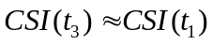, or say, 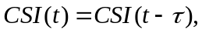 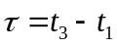

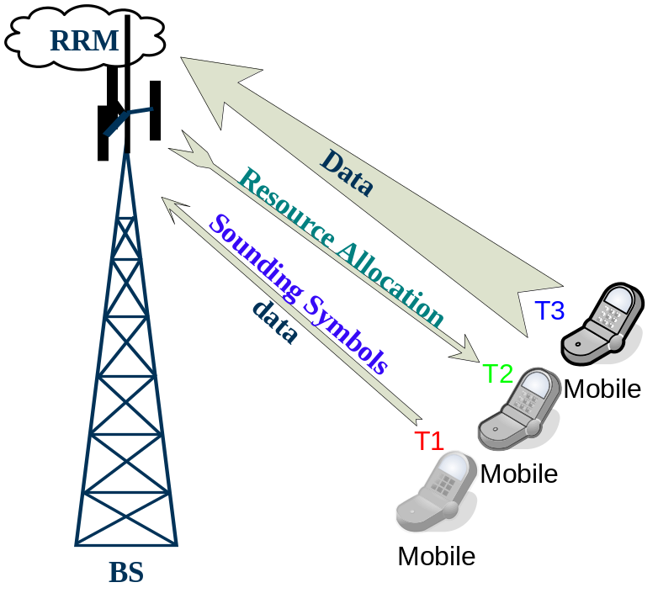
Fig. 1 Sketch map showing uplink CSI delay

Below is a brief flow chart showing how the RRM functions work in our system. The outdated CSI is the input to the scheduling, power control and link adaptation functions. After each transmission, we get an ideal CSI at the transmission moment. However, when this CSI is used to guide future transmission, it becomes outdated.

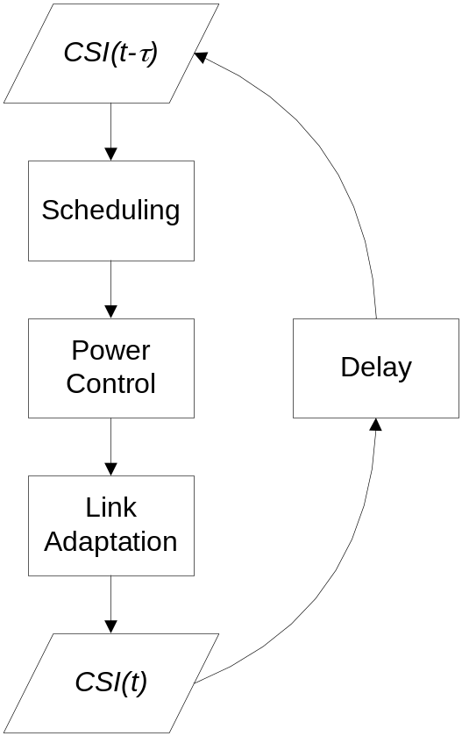

Fig. 2 Flow chart revealing relation between RRM functions and CSI while considering delay

2.2 Channel model
The distance attenuation between two terminals is determined using ‘standard’ radio propagation models with the path loss (L) as a function of the distance d, on the form as defined by equation below, and shadow fading is modelled as a log-normally distributed random variable.

L(d) = β +10 ⋅α ⋅ log10 (d) [dB]

The implemented channel model is based on the 3GPP spatial channel model (SCM) [7], which is a ray-based channel model that captures spatial and temporal channel characteristics.

The spatial channel model models rays between a pair of terminals. The rays are divided into paths and sub-paths. A path is a group of rays, or sub-paths, with similar delay. For every link the same number of paths (N) is modelled, each path comprising M sub-paths. In 3GPP
SCM, there are six paths and 20 sub-paths per path. Each sub-path is modelled with a delay, amplitude, a phase and with an angle at the transmitter and the receiver side. Fig.3 illustrates all 120 rays in the 3GPP SCM travelling between one specific antenna element on the base station side and one specific antenna element on the mobile side.

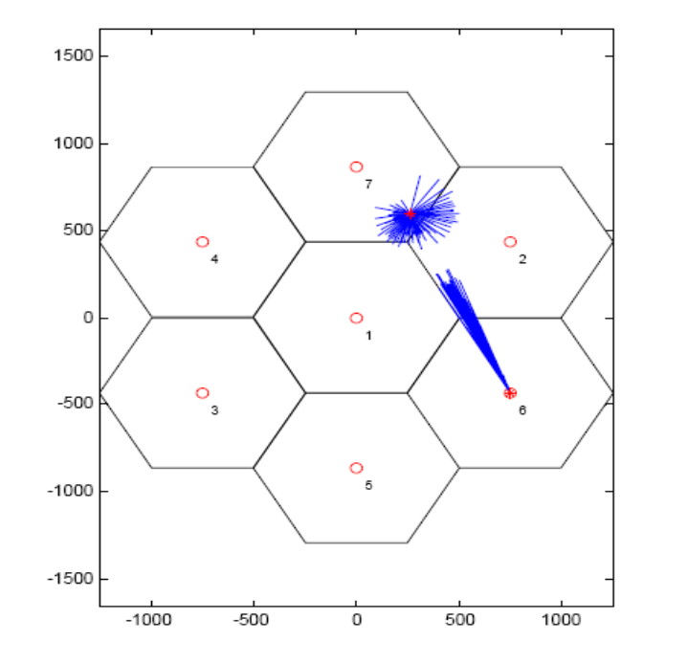
Fig. 3 Ray based channel model

The length of each ray, both at the base station and the terminal side, does indicate the corresponding delay. The mobile antenna is surrounded by rays, which creates an almost perfect Rayleigh like surrounding around the mobile. Fig.4 illustrates a realization of a multi-path fading channel.

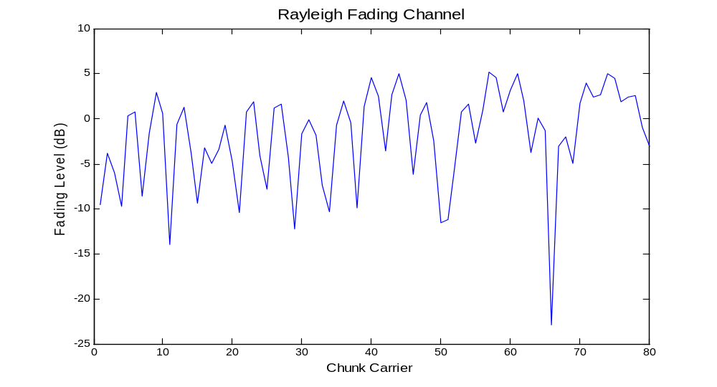
Fig. 4 One Rayleigh channel realization in frequency domain

2.3 Time-frequency structure
Time and frequency resources are structured in different units. The smallest unit in frequency is the sub-carrier and the width of such a sub-carrier is called the sub-carrier bandwidth.
Several consecutive sub-carriers form a chunk-carrier and the entire bandwidth, comprising all the chunk-carriers, is simply denoted a carrier. The smallest time unit is the symbol time, which corresponds to the duration of an OFDM symbol (including cyclic prefix). A frame is a set of (in time) consecutive OFDM symbols and multiple frames constitute a super-frame.

The combination of a specific sub-carrier and a specific OFDM-symbol (symbol time) is referred to as the ‘symbol’. Similarly, the combination of a chunk-carrier and a frame defines a chunk (an OFDM resource block), which is the smallest entity that can be scheduled for transmission. Within a chunk the transmission parameters, like modulation scheme and transmit power, are (typically) held constant. Fig.5 gives a schematic picture of the adopted time-frequency structure.

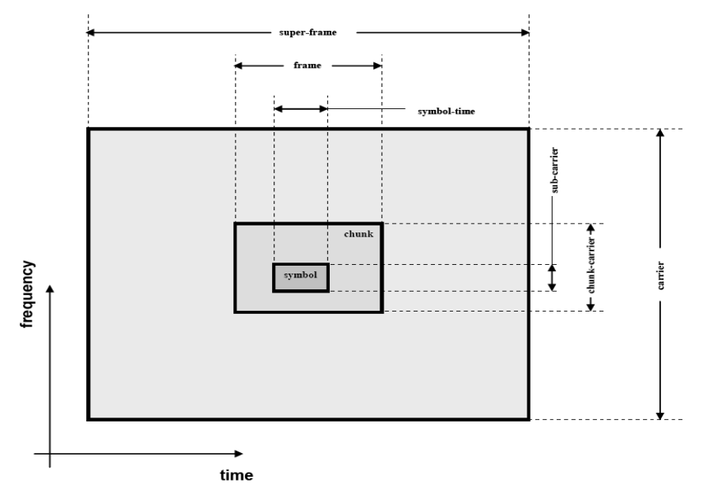
Fig. 5 Time-frequency structure

2.4 Channel State Information Metric
There are different metrics that may be used as CSI, adapted to different scenerios. The most common metric is SINR, which we will adopt in our study. In general, we can talk about short term CSI and long term CSI. The former aims to give an instantaneous value, while the latter captures higher order moments.

In our study, we aim at attaining short-term CSI. For each user, we try to obtain a chunk CSI by measuring the SINR in this chunk. With feedback delay:
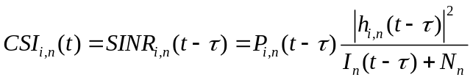
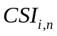 - CSI value of user in chunk
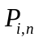 - Power allocated to user on chunkat time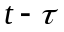.
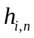 - Channel coefficient
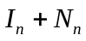 - Interference and noise power in chunk, 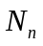 is assumed constant.

Since we adopt the instantaneous value of SINR as CSI metric, CSI value could vary from time to time (h, I, P parts’ variation). In order to make CSI a reliable indicator, we have to be informed of its variation properties. Many studies have been carried on to cope with the part variation [8], [9]. Our focus is to mitigate the part variation, i.e. inter-cell interference variation, since in a multi-cell system, the interference variation contribute most to the CSI variation under some scenario (low speed). One of the purposes of this thesis is to employ proper resource allocation strategies to mitigate inter-cell interference variation so as to increase CSI estimation accuracy.

2.5 Scheduling
The scheduling algorithm determines which user a chunk is assigned to in each frame. There are some figures of merits when judging a scheduler’s performance. In a system performance perspective, a scheduler should improve system throughput. In a user performance perspective, the scheduler should guarantee a certain quality of service (minimum data rate). Finally, implementation complexity has to be taken into account.

Below, we present four most commonly used schedulers. In the next chapter, we will exploit their properties under single cell scenario. Then, we will analyze their performance in a multi-cell system.

Round Robin (RR)
Round robin scheduler is a kind of “blind” (channel state independent) scheduler. It schedules users one by one without any selection process, and each scheduled user is offered the whole bandwidth. Thus, the time and frequency resources are equally distributed among all its serving users. No CSI is required for round robin scheduling.

Proportional Fair in Frequency domain (PFF)
Compared to RR, Proportional Fair in Frequency scheduler tries to exploit frequency domain multi-user diversity gain. In each frame, each chunk will be assigned to the user who enjoys best SINR compared to its average SINR among the entire bandwidth. That is, for chunk, user will be picked if it satisfies:

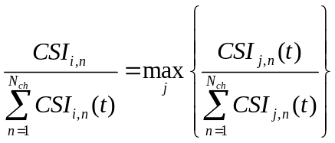

is the CSI value of user on chunk , 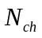 is the number of chunks divided in the whole bandwidth. We can see that the PFF scheduler tries to schedule users in their multi-path fading peaks.

Proportional Fair in Time and Frequency domain (PFTF)
Compared to PFF, Proportional Fair in Time and Frequency scheduler adds fairness concern in time domain. It doing this by assigning each chunk to a user who is experiencing the best instantaneous SINR in this chunk compared to its average SINR over time and frequency domains. That is, the winner of chunk among its competitors should satisfy:

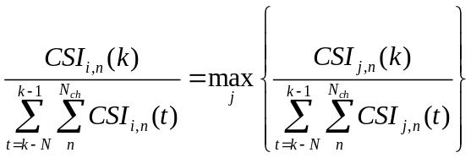

Where is the winner identity, 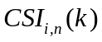 denotes the CSI value of user on chunk at time instant, is the time index. is the length of time sliding window.

Proportional fair schedulers make sure that each user can be scheduled when it is in a relatively good condition. Thus, system resources are better utilized while fairness among users at the same time is maintained.

Persistent scheduler
Fully dynamic scheduling allows for flexibility but it also leads to high signaling. To limit the signaling load for sources with regular arrival rate a concept referred to as persistent scheduling has been agreed in 3GPP. The idea is to assign resources on a long-term basis. The base station assigns semi-persistently time and frequency resources for each transmission attempt.

2.6 Power control
As agreed in [10], the uplink transmission power is set according the following formula:
P = min {P_{max,} 10logM + P₀ + α·PL + f(Δ_{i}) + Δ_{MCS} } [dBm]
- 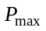 is the maximum allowed power for each user terminal
- M is the number of assigned chunks as indicated in the scheduling grant
- is cell specific path loss compensation factor
- PL is the path loss
- 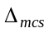 is a Modulation and Coding Scheme (MCS) specific offset
- 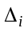 is a user specific offset or ‘closed loop correction.

We will now neglect the effect of and for simplicity. Below we give a method of choosing Po.

For a user with path loss PL and interference and noise power IN, let it transmit with full power and on the whole bandwidth (M = M₀), if its receiving SINR just reaches the target SINRo, then we can rewrite the above formula as:
P_{max} = 10logMo + P₀ + α·PL → PL = (P_{max} - 10logMo - P₀)/ α
SINRo = P_{max} - PL – IN - 10logMo = P_{max} - (P_{max} - 10logMo - P₀)/ α – IN
→ P₀ = α·(SINR₀ + IN) + (1–α)·(P_{max} – 10logM₀)

- SINR₀ is the required SINR target
- IN is the interference and noise power
- M₀ is the maximum number of chunks could be assigned to each user

Based on the expression of P₀ derived above, we will study how the target SINR and path loss compensation parameter could affect the transmission power allocation.

Fig.6&7 show how the settings of (1) can affect the power allocation. Given a certain path loss and interference and noise level, the blue lines correspond to the transmission power allocated to user, and the red lines display the power allocated per chunk. We can see from Fig.6&7, the increase of α and SINR₀ can make the transmission power per user easier to reach its maximum, and thus the power allocated per chunk would vary with different chunk number being allocated.
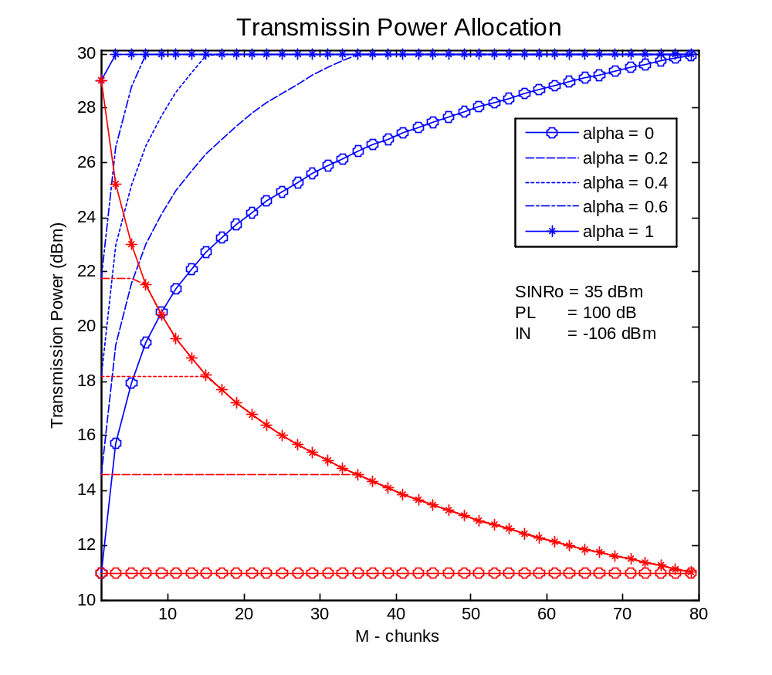
Fig. 6 Power per user and power per chunk according to different value of pathloss compensation parameter
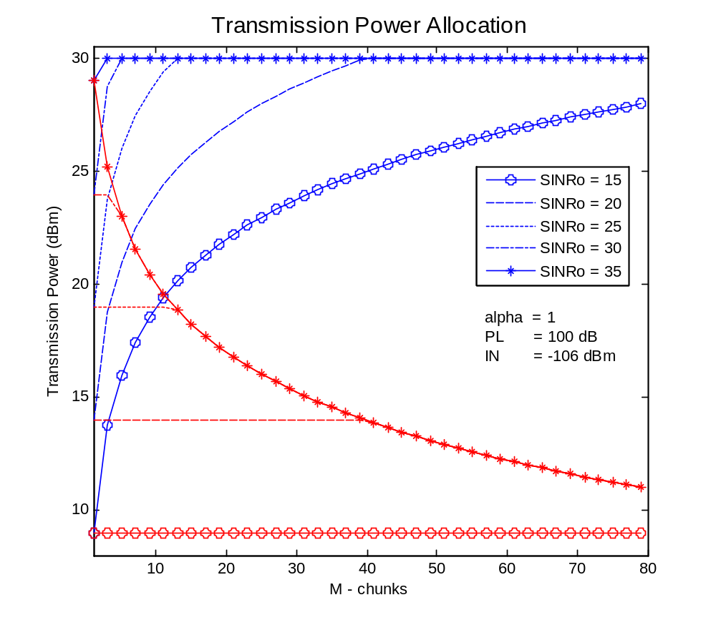
Fig. 7 Power per user and power per chunk according to different SINR target

We will study two extreme cases:
- Bandwidth Dependent Power Control
Here, we don’t apply any path loss compensation, that is: set α equal to zero. Thus,
P₀ = P_{max} – 10logM₀
And
P = P_{max} – 10logM₀ + 10logM [dBm]
Note that in this case, we keep the transmission power on each chunk constant, and the total transmission power allocated to a user is dependent on the number of chunks (bandwidth) allocated to it.

- Fixed Power Control
Here, we give each user full path loss compensation, α=1.
Now,
P₀ = SINR₀ + IN
And
P = min{P_{max,} 10logM + SINR₀ + IN + PL } [dBm]
In this case, more power is needed for pass loss compensation and SINR target fulfilment. We can see that, for large path loss or high SINR target, even a user being assigned only one chunk, it will transmit with full power (Pmax). Thus, if we choose SINRo large enough (>50dB), the transmission power
P = P_{max} [dBm]
which always holds.

2.7 Link Adaptation
The link adaptation algorithm adapts the transmission parameters, like modulation scheme and channel coding rate, to the channel characteristics. In our system, fast link adaptation is supported, that is, modulation and coding rate are adjusted in a frame basis. The aim of link adaptation is maximum data rate (spectral efficiency). For the uplink case, in each frame, more than one user may be scheduled, and all the chunks assigned to a user form a block, which is the modulation and coding selection unit.

1
2
1
3
2
1
User #1 block 1
User #2 block 2
User #3 block 3
frame
frequency
chunk

Fig. 8 Illustration of transmission block

The modulation and coding rate selected for each block is to maximize the number of information bits that could be carried reliably in each block.

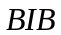 - Block information bits
 - Modulation rate
 - Coding rate
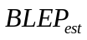 - Estimated block error rate

- Ideal Link Adaptation
With ideal link adaptation, the user bit rate is determined by its SINR. Note that for multi-carrier OFDM system, each chunk may experience quite different SINR, so we have to rely on effective SINR which would take into account the SINR variation among chunks. The mutual information based SINR metric recommended in [10] will be employed for effective SINR calculation.

See below is a simplified example on how the system chooses modulation scheme and coding rate for a block when given a certain SINR level.
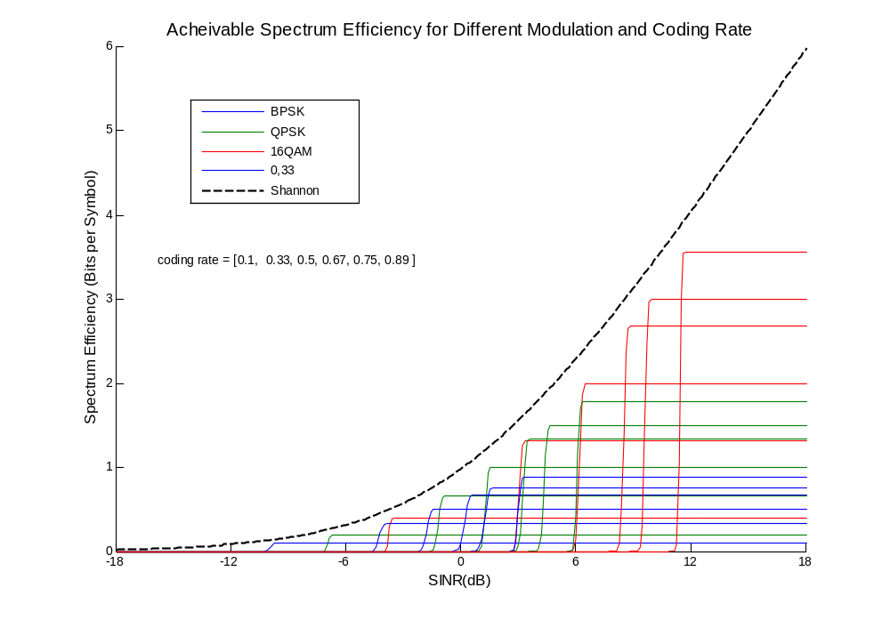
Fig. 9 Adaptive modulation and coding selection criteria

Fig.9 displays a table used for modulation and coding selection for transmission blocks. Different colours represent different modulation clusters, and curves sharing the same colour correspond to different coding rates given a fix modulation selection. In the figure, each mode is trained through extensive link level simulations. The results are store as a lookup table while applying modulation and coding selection, whose goal is to maximize spectrum efficiency.

With perfect SNR knowledge, we can adjust transmission data rate by adjusting modulation and coding rate. Achievable data rate approaches Shannon limit when SNR is low.

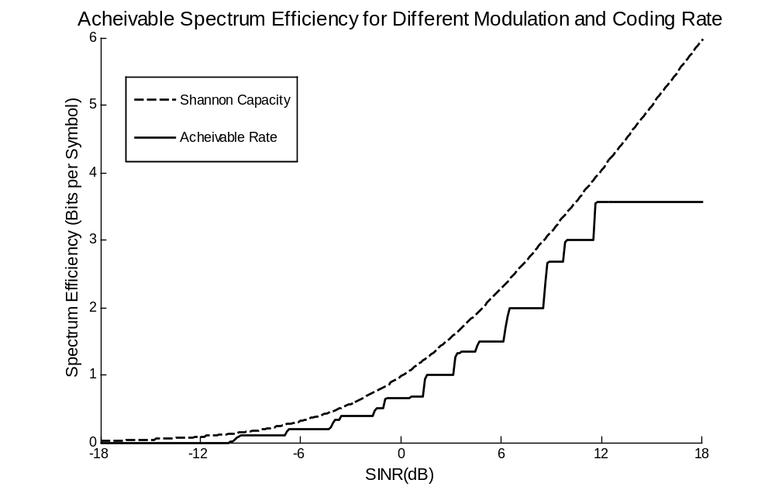
Fig. 10 Ideal link adaptation limit

- Non-ideal Link Adaptation
In our non-ideal link adaptation case study, CSI is the input to the link adaptation algorithm. Thus, to make a proper choice of transmission mode, CSI should approach the real SINR value. Notice in Fig.9, the left edge of each curve is sharp, especially for high modes. This property poses high requirement on SINR estimation accuracy, since even a slight overestimation on SINR will almost certainly result in a transmission failure. Both over and under estimation on SNR will result in link adaptation errors, and finally the waste of resources.

3. Scheduler and Power Control Performance in Single Cell Systems

Since we would like to study decentralized resource allocation schemes, we could start by studying the scheduling and power control schemes in a single cell system. For a certain cell, its performance in single cell system gives an upper limit of its performance in multi-cell system, because:
- There is no inter cell interference, so the user’s SINR is optimized compared to multi-cell case.
- There is no interference variation in time, so the CSI prediction reaches its highest accuracy.

3.1 Simulation Environment
Our studies are based on simulation results generated from a system level simulator developed within Ericsson, and there are some basic assumptions.

1. User distribution: uniformly
Users are uniformly distributed in each cell. When modeling single cell system, the cell load is the exact number of users in the cell. While studying multi-cell system, cell load is the average number of users in each cell

2. Traffic mode: Full buffer; No come and go
We study full buffer traffic mode, which means each user always has data to transmit, and since our simulation time is short (0.5s), we neglect the possibility of new comer and leaver.

3. Duplex scheme: uplink FDD
We study uplink because we believe uplink transmission suffers from more serious interference variation, and we model FDD duplex scheme so that uplink transmission can happen in each frame.

4. Single Input Single Output (SISO) Antenna System

Table 1 lists some important parameters set for simulations

To have a clear idea of how the scheduler and power allocation works, we first consider a “friendly” environment: lower user speed environment. In this case, the wireless channel varies slowly. The following Fig.9 is a realization of the channel fading variation in time, the fading amplitude accounts for path loss, slow fading(shadow fading) and fast fading (Rayleigh fading). We can see that the fading variation in time is smooth due to the low user speed (1 m/s). The noise power is assumed constant.

Cental frequency | 2 GHz
Total bandwidth | 20 MHz
Sub-carrier bandwidth | 15 kHz
Number of subcarrier | 1280
Number of chunk carrier | 80
Number of subcarriers per chunk | 16
Frame duration | 1 ms
Traffic mode | full buffer
Cell load | 5, 10, 20 users/cell
User speed | 1 m/s
Base station per site | 1
Cell radius | 500 m
Number of cells | 1, 7(multi-cell)
Noise power | -159 dBm
Maximum Mobile Power | 1 w
CSI feedback delay | 2 ms
Persistent scheduling interval | 10 ms
HARQ mode | incremental redudency
Table 1 Simulation Parameters

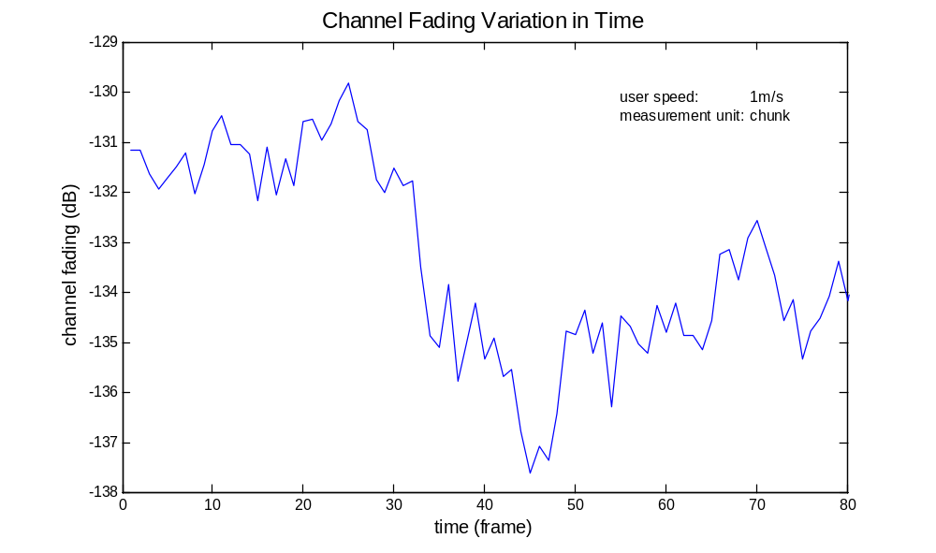
Fig. 11 One channel realization over time in one chunk

3.2 System Performance with Fixed Output Power
In this section, we will study the system performance under different scheduling strategies when fixed output power is applied. Every user transmits with the maximum power allowed, and each chunk is allocated a portion of the maximum power, this portion will change and depends on how many chunks in total are scheduled for a certain user.

Firstly, we study the performance of three schedulers: RR, PFF and PFTF. The criteria during the evaluation of their performance are system (cell) throughput and user throughput (coverage).

Fig.12&13 show that system throughput and user throughput distribution that could expect when applying different scheduling schemes.

We make the following observations:

- PFF performs best in the sense of improving the whole system throughput, followed by PFTF. RR serves as a reference case.
- With increased cell load, the multi-user diversity gain exploited by PFF and PFTF becomes obvious. More users bring more throughput gain. However, this is not the case when we employing RR: the average throughput is unchanged despite more users join the system
- We define the 10th percentile user throughput is the coverage for the system. PFTF provides the best service for cell edge users. PFF scheduler sacrifices the cell edge users’ benefits for achieving higher system throughput, making its coverage even worse than RR.
- Compare the PFF and PFTF’s user throughput distribution. We can see: in PFTF, about half (45% in the figure) of the users who enjoys better channel conditions sacrifice their benefits by allocating more resources to the other half bad condition users. Thus, the underprivileged users are not too underprivileged, while the privileged users are not trying their best.
- PFTF is consistently outperforms RR in both throughput and coverage.

Shortly put, our finding is that compared to PFF, PFTF adds additional fairness concern in the time domain. That is why PFTF provides better coverage.

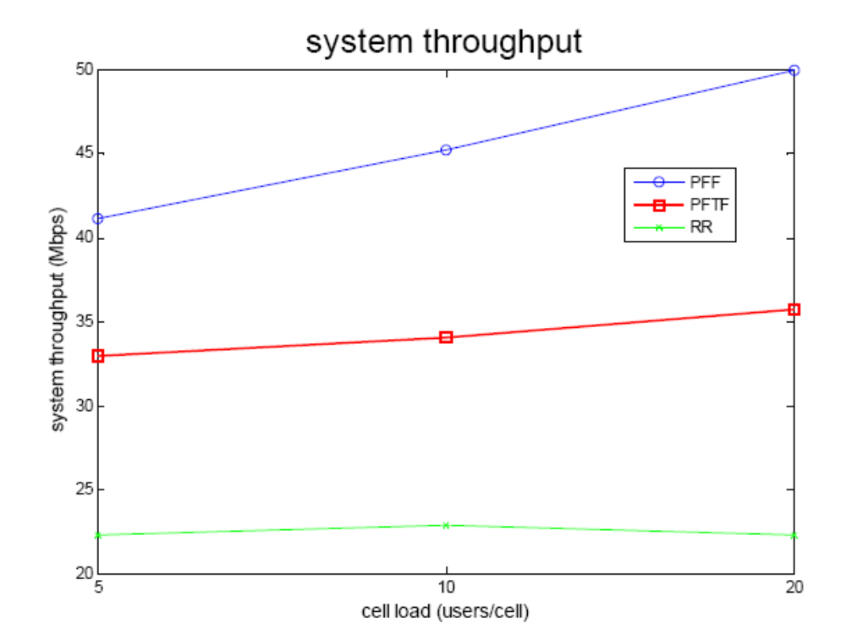
Fig. 12 System throughput while employing different schedulers in single cell system with ideal link adaptation
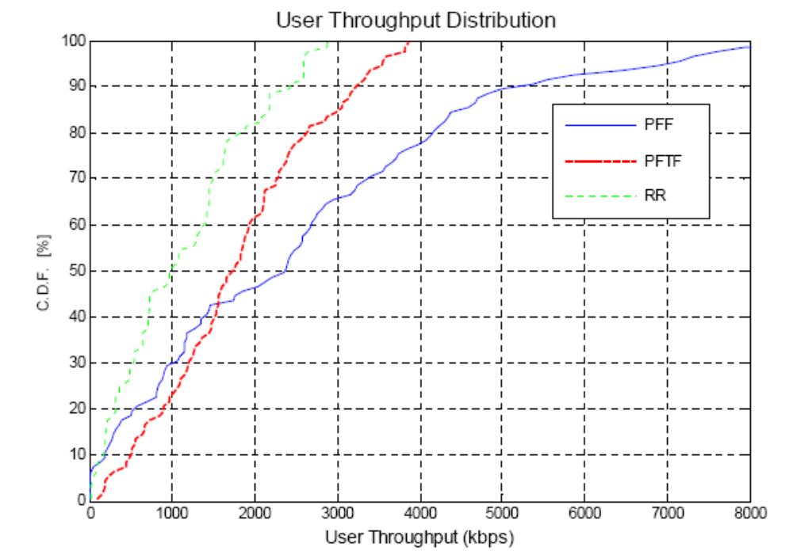
Fig. 13 User throughput distribution while employing different schedulers in single cell system with ideal link adaptation

Next, we study the “time coherence” of a scheduler. That is, how probably the scheduler would maintain its scheduling decision in the following frames. We will look at “user coherence” and “chunk coherence” respectively.

Fig.14 shows the user coherence, which is defined as the probability that a chunk being scheduled to the same user for a number of consecutive frames. X-axis shows the number of consecutive frames that a chunk being scheduled for the same user, y-axis shows the probability.

Observations:
- The PFF scheduler shows the highest user coherence, even after 10 frames, the coherence is still larger than eighty percent. PFTF shows quite smaller coherence, the probability drops to zero after three consecutive frames. For RR scheduler, there is no user coherence at all.
- For both PFF and PFTF scheduler, user coherence will decrease with increased cell load. This because the competition for each chunk is more intense with increased users.

Analysis:
The user coherence drops dramatically in PFTF compared to PFF because the time domain fairness consideration brings unstable factor to the performance of PFTF. In PFTF, if the scheduler assumes the user’s previous channel conditions are poor, it will give priority to the user’s present transmission. The validity of the assumption may fail; causing the scheduler fluctuates in its scheduling decision even in low speed scenarios.

1
2
3
4
5
6
7
8
9
10
0
10%
20%
30%
40%
50%
60%
70%
80%
90%
100%
Frame
Probability that A User being Scheduled in Consecutive Frames

PFF 5 user/cell
PFF 10 user/cell
PFF 20 user/cell
PFTF 5 user/cell
PFTF 10 user/cell
PFTF 20 user/cell
Fig. 14 User coherence for different scheduling schemes and cell load

We now examine the chunk coherence of a scheduler. The chunk coherence is defined as the probability of a certain number of chunks being assigned to an active user. If a user keeps receiving a fixed number of (other than zero) chunks all the time, the chunk coherence is high. Fig.15 shows the probability distribution of the number of chunks a user may expect to be scheduled in each frame. The total number of chunks is 80, and five users compete for it.

Observations:
- For PFF scheduler, each user may expect to transmit in each frame. Though the number of allocated chunks may vary, it is more or less around its average.(16 = 80/5 in this case)
- For PFTF scheduler, each user has 75% probability to transmit in each frame. Once a user being scheduled, the number of chunks being assigned to it is more or less uniformly distributed with a slight crowd in low chunk numbers. (less than 10)
- For RR scheduler, a user has 20% probability to be scheduled (inverse proportional to the total number of users), once scheduled, the user being assigned all the chunks (80).

Analysis:
- The chunk coherence is a complement for the user coherence to reveal the stability of a scheduler. That is, if a scheduler tends to schedule the same user in consecutive frames, and assigns more or less a fixed number of chunks to each user, we say that the scheduler behaves stable In this case, the received power in each chunk seen by the base station is stationary and also the interference this chunk may cause to other cell(s).
- User coherence and chunk coherence are highly related. High user coherence surely means high chunk coherence, though the inverse does not (necessarily) hold. We expect that a scheduler is stable in time because we would like the scheduled users generate stable interference over time. This is not particularly relevant in the above ideal link adaptation single cell study, but is of high importance when we switch to multi-cell system and consider non-ideal link adaptation.
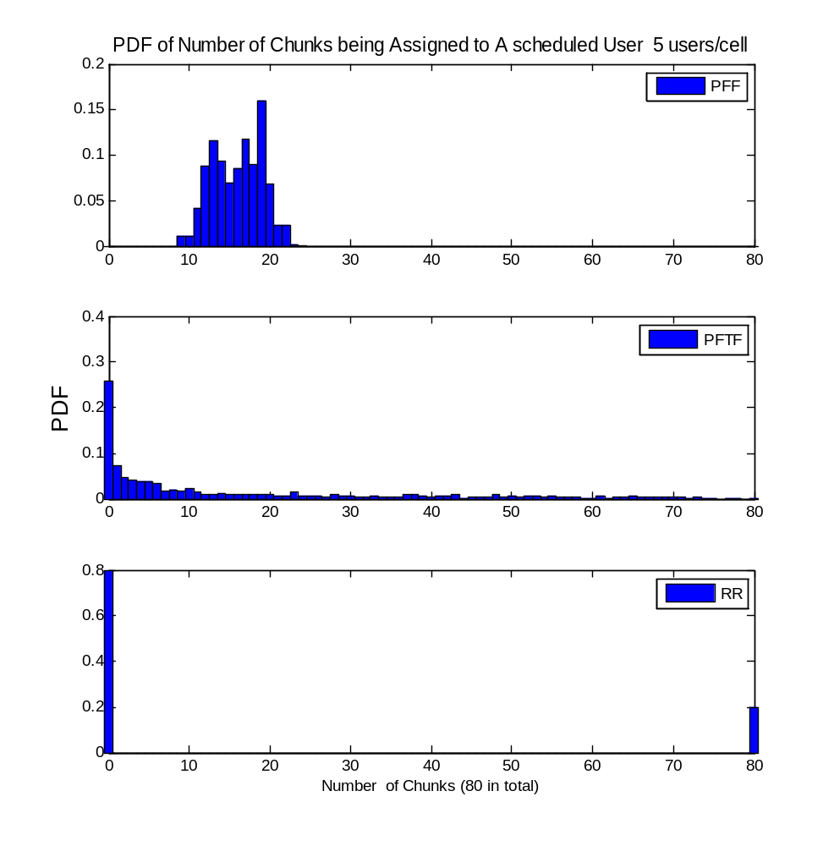
Fig. 15 Chunk coherent for different scheduling schemes with fixed output power

3.3 System Performance with Bandwidth Dependent Power Control
Bandwidth dependent power is implemented by allocating fixed transmission power on each chunk. Thus, instead of always transmitting with maximum power, a user adjusts its transmission power proportional to the bandwidth (chunks) being assigned to it.

Notice in Fig.12, the throughput gain of PFF and PFTF over RR may due to their exploitation of channel variation, but also due to transmission power’s increase during PFF and PFTF’s scheduling. To be explicit, RR can scheduler only one user at a time, and this user will transmit in the whole bandwidth, so each chunk can only get a minimum portion of the maximum transmission power. While for PFF and PFTF schedulers, several users could divide and share the whole bandwidth, so the transmission power allocated to each trunk can be larger than RR case. This increase of transmission power could increase SNR and further data rate. To make a fair comparison of the three scheduler’s ability on exploiting multi-user, multi-channel diversity gain, we apply bandwidth limited power control to PFF and PFTF.

Fig.16&17 show the system and user throughput performance while applying bandwidth limited power control to the system. Compared to Fig.12&13, Fig.16&17 add power control performance with dashed lines.

Observations:
- System throughput decreases for both PFF and PFTF schedulers while employing power control, but still gains a lot compared to RR which attributes to their exploitation of multi-channel multi-user diversity gain.
- On the system throughput point of view, the difference between PFF and PFTF is diminished when applying power control. They behave similar to each other.
- The system coverage (10th percentile user throughput) decreases for both PFF and PFTF since less transmission power available for every user.
- The advantage of PFF over PFTF by providing larger coverage maintains.

Analysis:
From Fig.16 we can see, while employing power control, the gain of PFF over PFTF disappears. As mentioned in the beginning of this section, the gain of PFF and PFTF over RR comes from two sources: the multi-channel multi user diversity gain, as well as transmission power gain. While we eliminate the later factor by applying bandwidth limited power control, we find that the ability of exploiting diversity gain for PFF and PFTF is the same. However, this is not enough for us to conclude that when not applying power control, the system throughput gain of PFF over PFTF is due to the transmission power gain of PFF over PFTF. We will make this clear after further analysing the user and chunk coherence performance while applying power control.
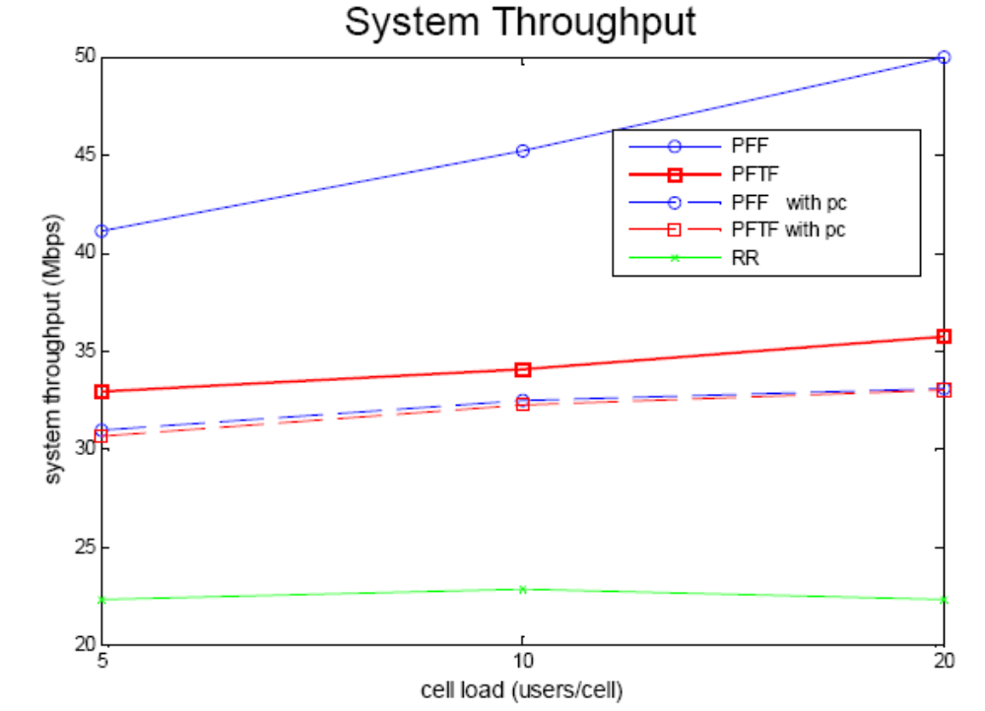
Fig. 16 System throughput while employing different schedulers in single cell system with ideal link adaptation
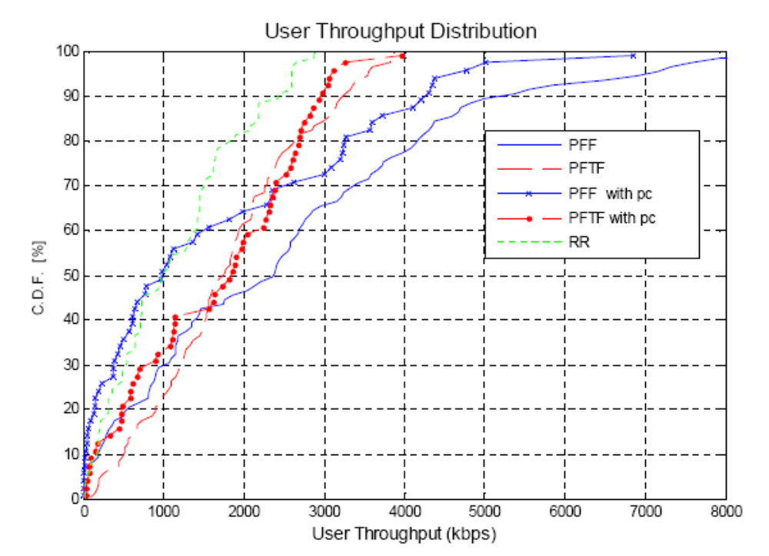
Fig. 17 User throughput distribution while employing different schedulers in single cell system with ideal link adaptation

Fig.18-20 display the user and chunk coherence performance for different schedulers while applying power control.

Observations:
- The user and chunk coherence increases for both PFF and PFTF schedulers with the help of power control.
- For PFTF scheduler, the improvement of user and chunk coherence is dramatic.

1
2
3
4
5
6
7
8
9
10
0
10%
20%
30%
40%
50%
60%
70%
80%
90%
100%
frame
Probability that A User being Scheduled in Consecutive Frames

PFF with pc 5 users/cell
PFF with pc 10 users/cell
PFF with pc 20 users/cell
PFTF with pc 5 users/cell
PFTF with pc 10 users/cell
PFTF with pc 20 users/cell
Fig. 18 User coherence for different scheduling schemes and cell load

1
2
3
4
5
6
7
8
9
10
0
10%
20%
30%
40%
50%
60%
70%
80%
90%
100%
frame
Probability that A User being Scheduled in Consecutive Frames

PFF 5 user/cell
PFTF 5 user/cell
PFF with pc 5 users/cell
PFTF with pc 5 users/cell

Fig. 19 User coherence for different power control strategy

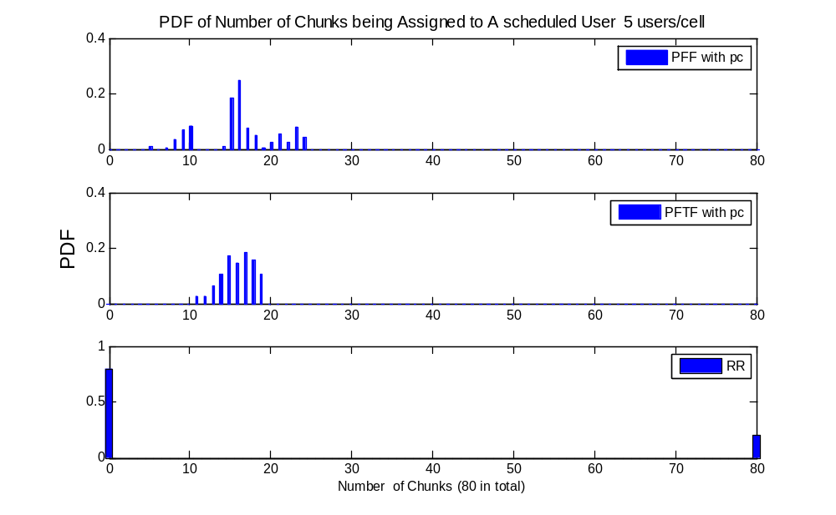
Fig. 20 Chunk coherent for different scheduling schemes with bandwidth dependent power control

Analysis:
Clearly, the power control strategy actually affects the scheduling decisions. To fully understand this phenomenon, we need to revisit to the CSI estimation method applied in our study. Fig.21 shows the CSI value variation in time. The upper picture shows how the CSI value varies for different scheduling and power control schemes. The lower picture displays the corresponding channel fading variations.

Observations:
- Without power control (solid lines), under PFF scheduling, the CSI varies following the trend of channel fading, just a number of frames delay. However, under PFTF scheduling, the CSI fluctuation is much stronger than channel variations.
- While applying power control, the absolute value of CSI decreases for both PFF and PFTF. The CSI curves are merged for the two schedulers and follow the channel fading trend.

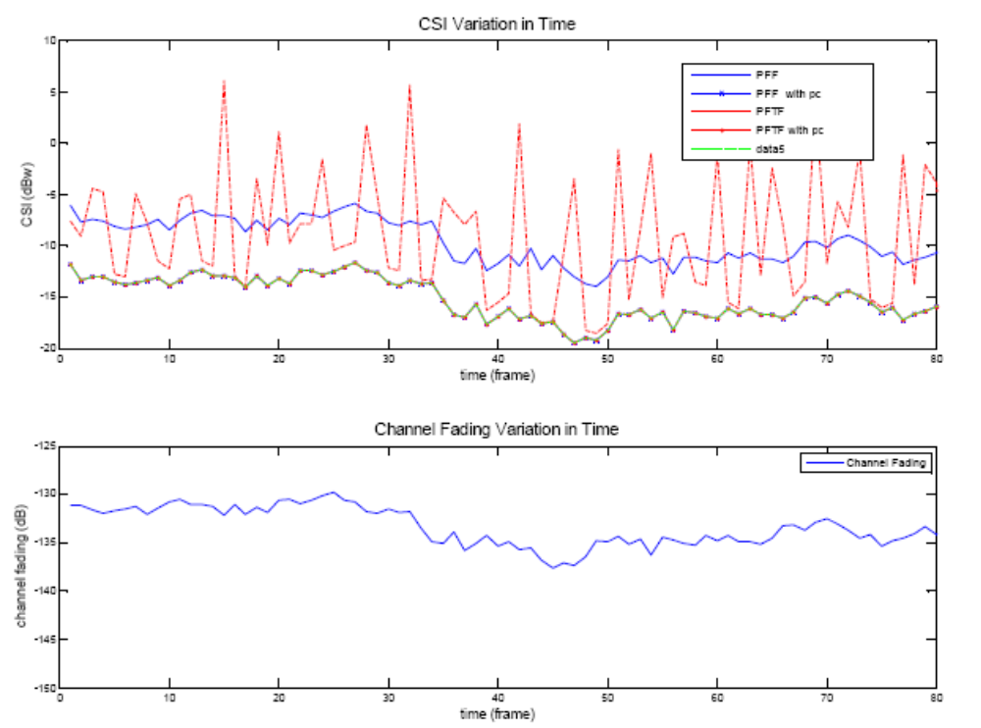
Fig. 21 CSI and channel coefficient variation over time

Analysis:
The CSI estimation function on which we base the previous studies can be expressed as:
In our low speed single cell study, the channel coefficient and interference plus noise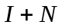 could be reliably estimated by sounding signals, while the sounding weightis dependent on the previous transmission power and is subject to the previous scheduling and power control decisions. is the previous transmission power allocated to chunk .Under PFTF scheduling, when we don’t apply power control, from Fig.13 we can see that chunk coherence is very low, since is inversely proportional to the number of chunks, the coherence of in time is also very low. In this case, the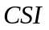value could not be stabilized though the channel condition and interference plus noise level are quite stable in our study. When we fix by applying bandwidth limited power control, CSI variation can only be induced by variation. That is why the CSI curve in this case follows the trend of. For PFF scheduler, since the chunk coherence is always high regardless of power allocation schemes, in more or less a constant over time, so it could follow the trend of channel fading even without assistance from power control.

3.4 System Performance with Non-ideal Link Adaptation
The above studies are based are ideal link adaptations. That is, the system can always choose a proper modulation and coding scheme for each transmission block so that the data rate is optimized under constraints of channel conditions. To realize this, we control the input to the link adaptation algorithm as ideal SNR instead of CSI estimation. But in reality, this is not always the case. The CSI estimation error can directly lead to link adaptation error.

Fig.22&23 show the system performance when we take into account the influence of imperfect CSI estimation on link adaptation performance.

Observation:
- System throughput and coverage are not affected under PFF scheduling by non-ideal link adaptation. Same situation holds for PFTF accompanied with power control. (Compare with fig 5&6)
- For PFTF scheduler, both throughput and coverage are harmed. The system throughput is even worse than the situation when less transmission power is invested (power control). And its coverage advantage over PFF is missing.

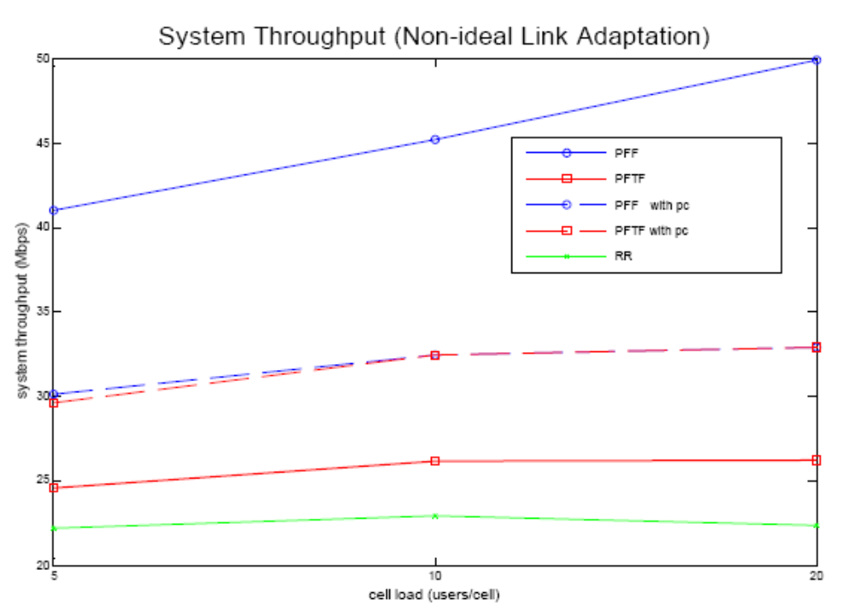
Fig. 22 System throughput while employing different schedulers in single cell system with non-ideal link adaptation

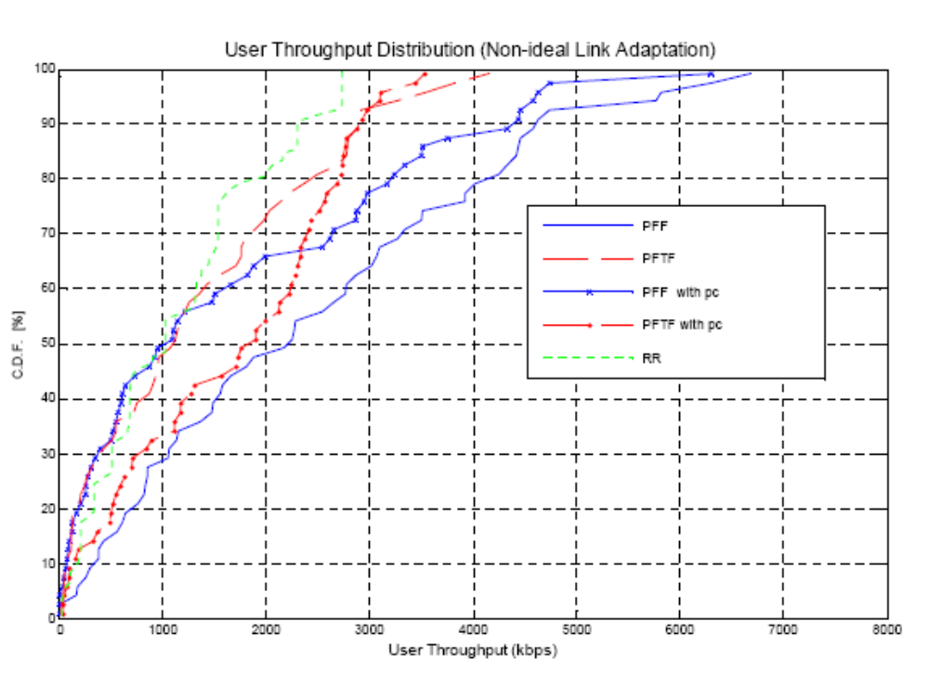
Fig. 23 User throughput distribution while employing different schedulers in single cell system with non-ideal link adaptation

Analysis:
The degradation of system performance in non-ideal link adaptation case is due to the CSI estimation error. The CSI estimation error due to feedback delay can be expressed like::
Large variation in SNR and CSI will bring large estimation errors to CSI. Fig.24 shows the CSI estimation error calculated for different schedulers. PFTF scheduling brings largest estimation error. This is consistent with the results shown in Fig.19, where PFTF displays the strongest CSI variation in time.

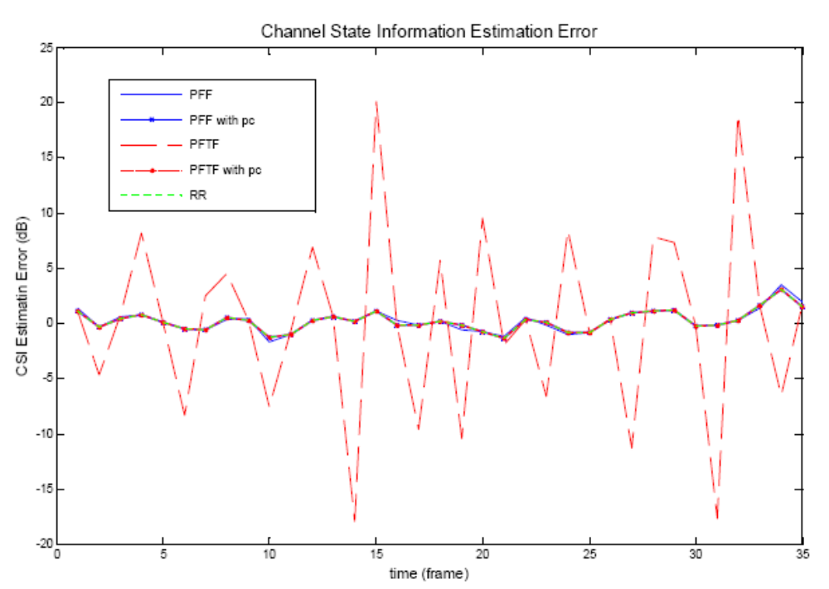
Fig. 24 CSI estimation error

3.5 Conclusions of the Single Cell Study
Based on above studies, we make the following conclusions:

- SNR variation determines CSI variation
- Reducing SNR (CSI) variation can improve CSI estimation accuracy.
- Accurate CSI estimation is important for increasing scheduling efficiency.
- Accurate CSI estimation is crucial for link adaptation performance.
- Schedulers with high stability (user and chunk coherence) can mitigate CSI variation.
- Bandwidth limited power control can help PFF and PFTF increase stability.

4. Scheduler and Power Control Performance in a Multi Cell System
In this chapter, we will extend our study to multi-cell system. Here, inter-cell interference is involved in system evaluation. Accordingly, the CSI metric is extended from SNR to SINR.

From the single cell study in Chapter 3 we know, mitigating CSI variation in time is beneficial in the sense of reducing link adaptation errors. It follows that in a multi-cell study, to reduce the CSI variation, reducing inter-cell interference variation (being an important cause to SINR variation) is of interest.

Thus, in this chapter, our focus is on mitigating inter-cell interference variations. To achieve this purpose, we start with analyzing the possible causes of interference variation. Then, we propose possible solutions.

4.1 Causes of Inter-cell Interference Variation
To be specific, there are three main reasons why the interference coming from neighbouring cells varies.

- Different users are scheduled in different time

Fast dynamic scheduling is performed every frame, so the interferers may change from time to time. Different interferes may cause different interference. Since we are studying a decentralized system, the scheduler in one cell have no information or influence on other cells’ scheduling decisions, we expect the scheduling decisions from neighbouring cells be as stationary as possible.

In this sense, we should propose schedulers showing high user coherence.

- Different power allocation

Not only the rapid change of interferers can bring about interference variations; even for a fixed interferer, its transmission power can also change. For fixed output power allocation, the transmission on each chunk is inverse proportional to the number of assigned chunks. In this case, schedulers showing high chunk coherence are of interest. However, for systems employing bandwidth limited power control, this is not an issue.

- Rayleigh fading

The rapid change of fading channels can also cause the interference power vary in time and frequency. This part is mainly dependent on the user speed.

4.2 Proposed Solutions
In a decentralized multi-cell system, base stations can not communicate with each other, but this does not mean they cannot be cooperative. Generating smooth interference is a great help for neighboring cells making effective interference estimation. Starting from this point, we propose some cooperative resource allocation solutions for multi-cell system management.

- Proportional Fair in Frequency Domain Scheduler (PFF)

As studied in chapter 3, PFF scheduler shows high user and chunk coherence in single cell. Intuitively in a multi-cell system, if given a friendly environment, it would like to behave friendly as well. Here, we see a potential win-win solution by applying PFF scheduling. To explain it more clearly, if the inter-cell interference variation is small in one cell (approach noise power variation in single cell system), by applying PFF, users from this cell can generate less variable interference to other cells. Thus, it may end up that all users in all cells generate smooth interference to others.

- Persistent Scheduling

Persistent scheduling is a direct solution to mitigate inter-cell interference variation, since it inherently eliminates the first and second causes of interference variations. Fig.25 shows how the interference changes with time while applying persistent scheduling every ten frames. The interference appears predictable during the persistence interval. Large estimation error only occurs at the switching points.

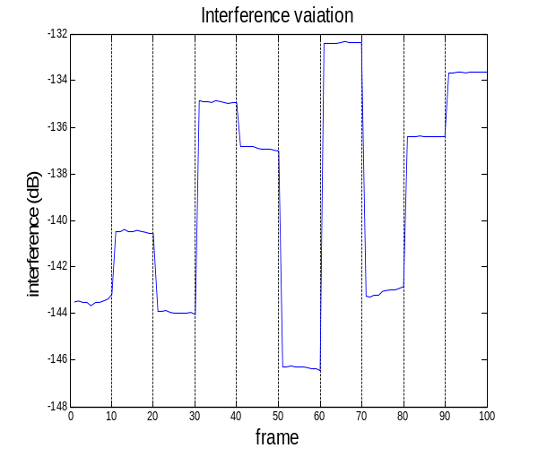
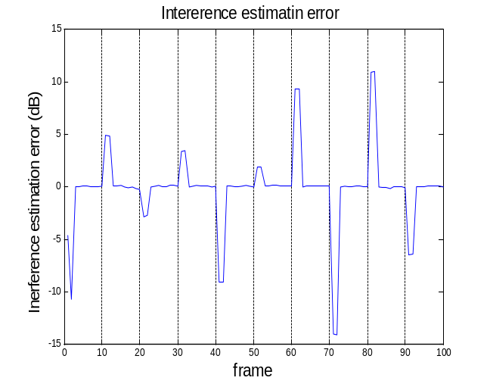

Fig. 25 Interference variation and estimation error while implementing persistent scheduler

- Bandwidth Dependent Power Control

As in the single cell study, bandwidth limited power control is also a promising candidate for multi-cell solutions.

In the following section, we carry out extensive simulations to gain insight into the multi-cell system behavior.

4.3 Simulation Results and Analysis
In this chapter, we will test the performance of our proposed as well as reference schedulers in a multi-cell system. Feedback delay and CSI estimation error are considered for scheduling and link adaptation algorithms. The main criteria for evaluation are system and user throughput. Inter-cell interference and CSI variation level are also studied in different scheduling and user speed scenario. Main simulation parameters are listed in table 1. Basic assumptions are same as single-cell system.

4.3.1 System Performance with Fixed Output Power Allocation

Fig.26 displays the simulation results for system throughput and user throughput while apply different scheduling schemes. For persistent scheduling, at scheduling point, we do the same user selection as a PFTF scheduler does.

Observations:
PFF exhibits the best system throughput performance.
When applying persistent scheduling to PFTF, system throughput has been improved.
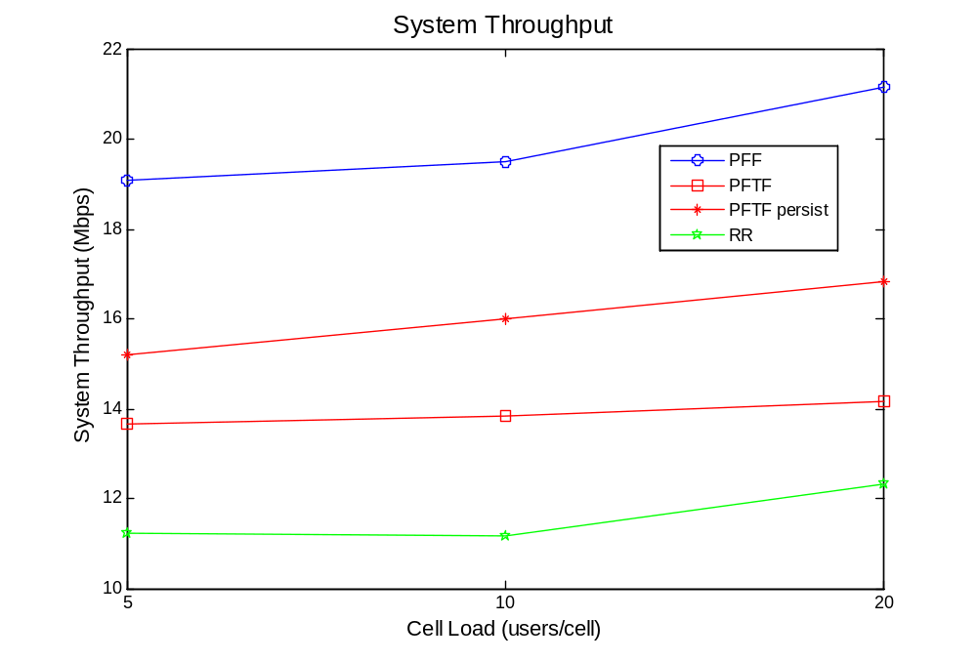
Fig. 26 System throughput while employing different schedulers in multi-cell system with non-ideal link adaptation
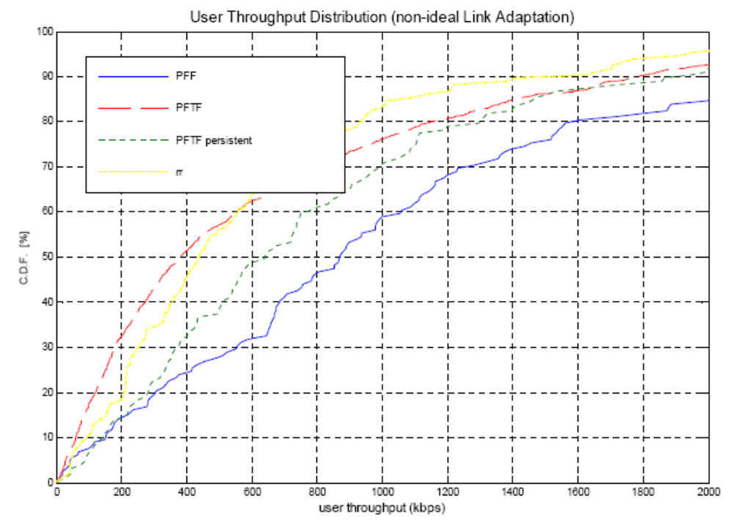
Fig. 27 User throughput distribution while employing different schedulers in multi-cell system with non-ideal link adaptation

Analysis:

Table.2 gives the interference and CSI estimation error corresponds to Fig.26&27.Persistent scheduling gives the least average estimation error. PFTF and RR show almost the same error level. PFTF is in between. Similar to single cell study, there are two aspects when judging a scheduler’s performance.
- The ability of exploiting multi-channel, multi-user diversity gain.
- Stability of CSI so as to reduce link adaptation errors.

With similar level of CSI estimation error, PFF and PFTF outperform persistent and RR schedulers respectively due to their better ability of exploiting diversity gain.

Besides, we can see with low user speed, interference estimation error contributes most to CSI estimation error.

 | PFF | Persistent | PFTF | RR
CSI estimation error (dB) | 2.4235 | 1.5324 | 5.8436 | 5.7857
Interference estimation error (dB) | 2.0903 | 1.3812 | 5.3559 | 5.3904

Table 2 Interference and CSI estimation errors for different scheduling schemes
with fixed output power

4.3.2 System Performance with Bandwidth Dependent Power Control
Fig.28&29 give the system performance when bandwidth limited power is employed.

Observation:
- System throughput is uniformly improved for all studied schedulers except for RR.
- Improvement is especially distinct for PFTF and its persistent scheduler.
- All schedulers except RR exhibit similar throughput and coverage performance.
- Unlike single cell system, the throughput loss due to transmission power decrease while applying bandwidth limited power control disappears.

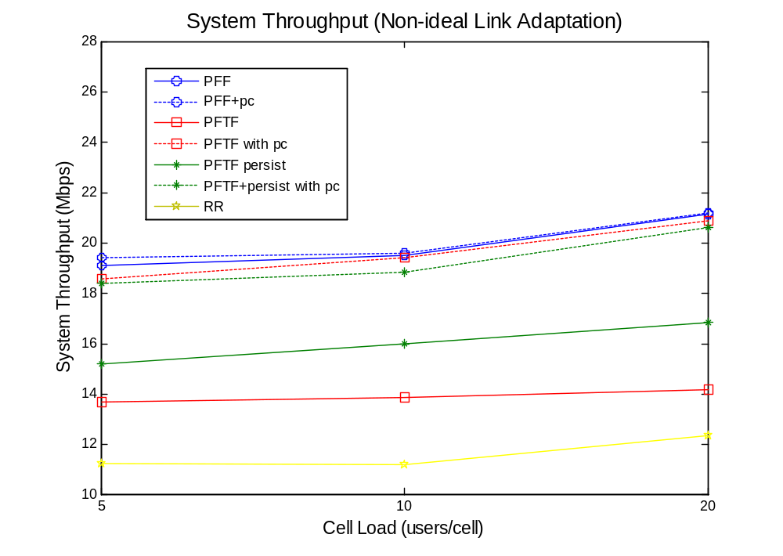
Fig. 28 System throughput while employing different schedulers in multi-cell system with non-ideal link adaptation

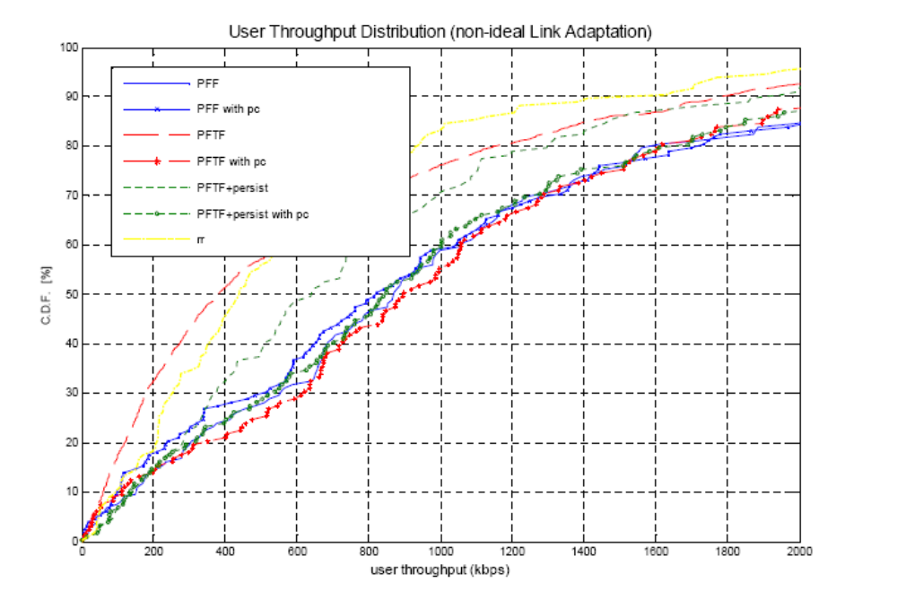
Fig. 29 User throughput distribution while employing different schedulers in multi-cell system with non-ideal link adaptation

 |  | System Throughput  Fixed Output Power  (Mbps/cell) | System Throughput  Bandwidth Dependent Power Control (Mbps/cell) | Gain by Power Control
5 users/cell | PFF | 19 | 19,1 | 0,5%
5 users/cell | PFTF | 13,9 | 18,5 | 33,1%
5 users/cell | Persistent | 15,3 | 18,4 | 20,3%
5 users/cell | RR | 11,2 | 11,2 | 0,0%
10 users/cell | PFF | 19,8 | 19,9 | 0,5%
10 users/cell | PFTF | 14,1 | 19,8 | 40,4%
10 users/cell | Persistent | 15,8 | 19,2 | 21,5%
10 users/cell | RR | 11,2 | 11,2 | 0,0%
20 users/cell | PFF | 21 | 21,1 | 0,5%
20 users/cell | PFTF | 14,3 | 20,9 | 46,2%
20 users/cell | Persistent | 16,3 | 20,8 | 27,6%
20 users/cell | RR | 12,2 | 12,2 | 0,0%

Table 3 System throughput (Mbps/cell) when applying different scheduling and power control schemes in studied multi-cell OFDM system
Table 3 shows the cell throughput each combination of scheduling and power allocation schemes can bring about. We can see that PFF and RR schedulers’ performance are power allocation scheme insensitive. Bandwidth dependent power control can bring only 0.5 percentage gain to PFF and none to RR. In contrast, PFTF and persistent schedulers are greatly benefit from bandwidth dependent power control, especially for PFTF whose throughput increases up to 46.2% in high load and 33% in low load. We can also see that after applying bandwidth dependent power control, all schedulers except RR give similar throughput performance.

PFF is a promising scheduler since it can always give the best performance and without the necessity of power control. Persistent scheduler is also preferable since it help PFTF increase 12 percents throughput without introduction of power control. Besides, persistent scheduler is beneficial from implementation point of view.

It is interesting to notice that PFTF scheduler performs worse than persistent scheduler with fixed output power, but performs better than persistent scheduler with bandwidth dependent power control. This is due to inherits of persistent scheduler. Persistent scheduler, by keeping scheduling the same users for a certain consecutive frames, can reduce inter-cell interference variations caused by interferers’ change. However, in the other hand, it gives up the benefits of quick adaptation also. With fixed power control, PFTF shows large CSI variation, under this circumstance, persistent scheduling displays its advantage of reducing interference variation. With bandwidth dependent power control, PFTF shows small CSI variation, thus, persistent scheduling exhibits the disadvantage of losing adaptation ability.

4.3.3 System Performance with Higher User Speed
While user speed increases, the CSI estimation error is mainly due to the rapid change of Rayleigh fading channels. Therefore, the effectiveness of our proposed cooperative scheduling, power control scheme is vanished. Fig.30&31 give an example of how the system throughput is harmed by increased user speed.
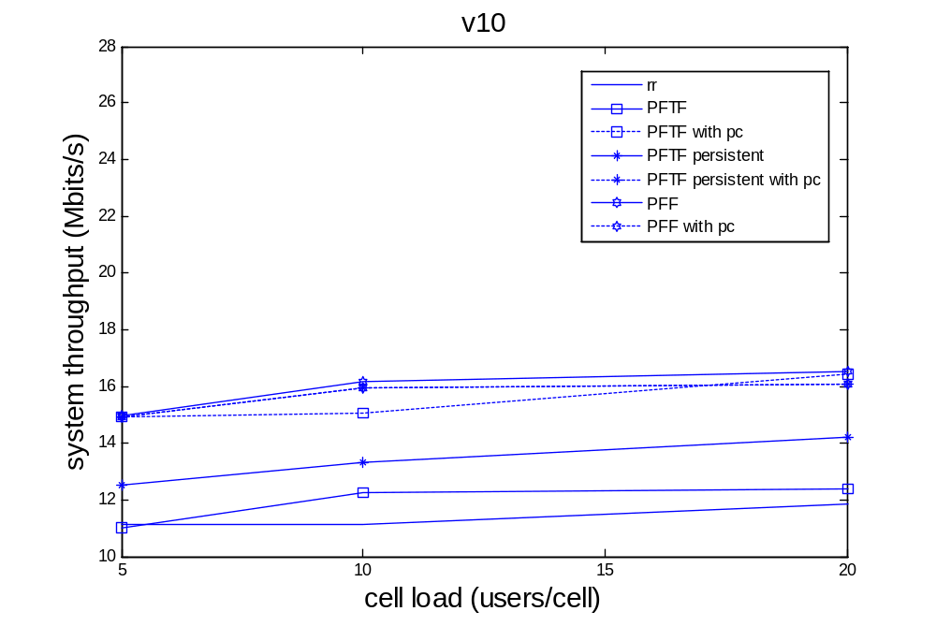
Fig. 30 System throughput performance with user speed 10 m/s

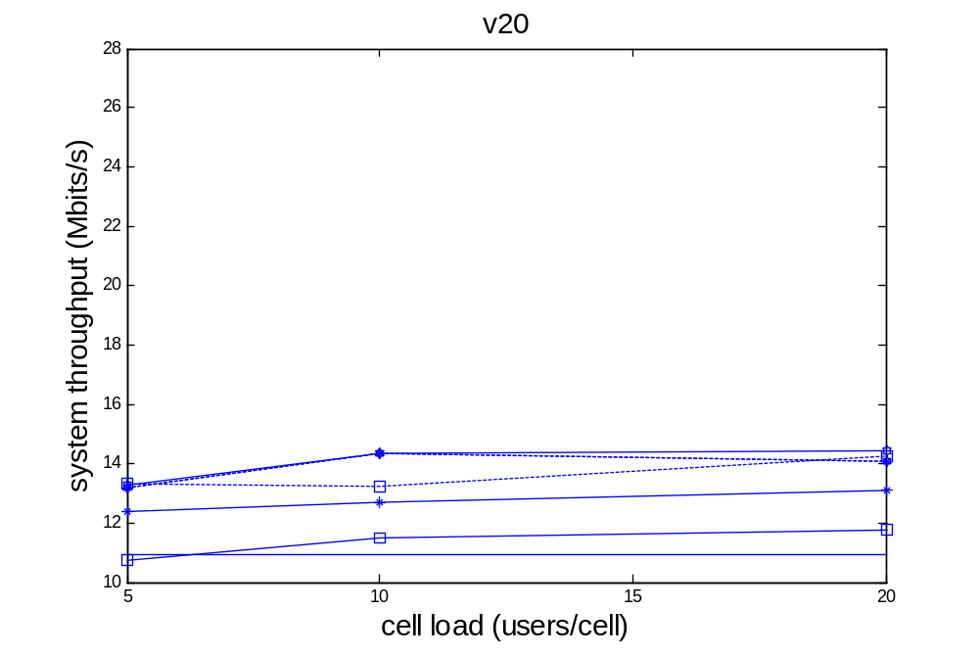
Fig. 31 System throughput performance with user speed 20m/s

5. Conclusions and Future Work

5.1 Conclusions
In this thesis work, we studied how different scheduling and power control strategies can affect system performance like throughput and coverage in uplink OFDM system. We employed system model and simulation tools which can account for channel state information (CSI) feedback delay and link adaptation errors. Studied schedulers include Round Robin (RR), Proportional Fair in Frequency domain (PFF), Proportional Fair in Time and Frequency domain (PFTF) and persistent scheduling. Two applications of 3GPP uplink power control formula which are termed as fixed output power and bandwidth dependent power control are evaluated.

Simulation results show that PFF scheduler gives the best system throughput performance, and can be seen as unaffected by different power allocation strategies. PFTF and PFTF with persistent scheduling are highly benefited from bandwidth dependent power control (almost equal performance as PFF), when compared to fixed output power. RR scheduler shows the worst throughput performance and is unaffected by power allocation schemes.

With fixed output power, the throughput performance order is PFF > PFTF with persistent > PFTF > RR, the differences are remarkable.
With bandwidth dependent power control, the throughput performance order is PFF > PFTF >PFTF with persistent > RR, the differences are marginal.

RR and PFTF with fixed output power provide worst coverage, while all the other scheduling and power allocation combinations exhibit similar coverage performance.

From a design point of view, we recommend PFF for achieving high system performance, or persistent scheduling for reducing transmission overhead and improving performance on large variation schedulers. Power control parameters can be adjusted to satisfy different requirements.

5.2 Future Works
Radio resource management is responsible for adapting transmission parameters to ever changing channel conditions in wireless communication systems. For radio management functions to work there’s a presumption that we could obtain channel state information accurately. However, due to some factors such as feedback delay, the channel state information can never be ideal. To combat this delay problem and approach as accurate CSI value as possible, there are mainly two ways to get there:

1. Smooth CSI variation in time.
In this case, CSI value obtained from previous measurement is still valid for future transmissions. That is, make the delayed channel state information as valuable as instantaneous one. This is what basically we do in the thesis. But of course, there is another alternative to cope with the feedback delay of CSI.

2. Advanced prediction algorithm
If we can predict future CSI based on previous measurement, we don’t have to worry about the CSI variation in that case. This is a very interesting area to be exploited in the future.

Reference:
- 3GPP TR 25.814 V7.1.0,”Physical Layer Aspects for Evolved Universal Terrestrial Radio Access (E-UTRA)”, Release 7, September 2006.
- Catreux, S.; Erceg, V.; Gesbert, D.; Heath, R.W., Jr.; “Adaptive modulation and MIMO coding for broadband wireless data networks”, Communications Magazine, IEEE Volume 40, Issue 6, June 2002 Page(s):108 - 115
- 3GPP TS 36.213 V8.0.0, “Physical Layer Procedures”, Release 8, September 2007.
- A. Pokhariyal, K. I. Pedersen, G. Monghal, I. Z. Kovacs, C. Rosa, T. E. Kolding, and P. E. Mogensen, “Frequency Domain Packet Scheduling Under Fractional Load for the UTRAN LTE Downlink”.
- Minghai Feng, Lan Chen, and Xiaoming She, “Uplink Adaptive Resource Allocation Mitigating Inter-cell Interference Fluctuation for Future Cellular Systems”, DoCoMo Beijing-Labs, Beijing, China
- Gabor Fodor and Chrysostomos Koutsimanis“A Low Intercell Interference Variation Scheduler for OFDMA Networks”, IEEE International Conference on Communications (ICC ’08), Beijing, China, May 2008..
- Castaneda, M.; Ivrlac, M. T.; Nossek, J. A.; Viering, I.; Klein, A.; “Outdated Uplink Adaptation Due to Changes in the Scheduling Decisions in Interfering Cells”, Communications, 2008. ICC '08. IEEE International Conference on 19-23 May 2008 Page(s):4948 - 4952
- Bonnet, J.; Auer, G.; “Chunk-based Channel Estimation for Uplink OFDM”, Vehicular Technology Conference, 2006. VTC 2006-Spring. IEEE 63rd Volume 4, 2006 Page(s):1555 - 1559
- Valenti, M.C.; Woerner, B.D.;”Iterative channel estimation and decoding of pilot symbol assisted turbo codes over flat-fading channels”, Selected Areas in Communications, IEEE Journal on Volume 19, Issue 9, Sept. 2001 Page(s):1697 - 1705
- 3GPP “3rd generation partnership project; Technical specification group radio access network; Spatial channel model for Multiple Input Multiple Output (MIMO) simulations”, 3GPP TR 25.996, V6.1.0
- Seong Taek Chung; Goldsmith, A.J.;”Degrees of freedom in adaptive modulation: a unified view”, Communications, IEEE Transactions on Volume 49, Issue 9, Sept. 2001 Page(s):1561 - 1571
- Brueninghaus, K.; Astely, D.; Salzer, T.; Visuri, S.; Alexiou, A.; Karger, S.; Seraji, G.-A.; ”Link performance models for system level simulations of broadband radio access systems”, Personal, Indoor and Mobile Radio Communications, 2005. PIMRC 2005. IEEE 16th International Symposium on Volume 4, 11-14 Sept. 2005 Page(s):2306 - 2311 Vol. 4 A
- Love, D.J.; Heath, R.W., Jr.;”Multimode precoding for MIMO wireless systems” Signal Processing, IEEE Transactions on [see also Acoustics, Speech, and Signal Processing, IEEE Transactions on] Volume 53, Issue 10, Part 1, Oct. 2005 Page(s):3674 - 3687
- Hongwei Yang;”A road to future broadband wireless access: MIMO-OFDM-Based air interface”, Communications Magazine, IEEE Volume 43, Issue 1, Jan. 2005 Page(s):53 - 60
- A. Pokhariyal, K. I. Pedersen, G. Monghal, I. Z. Kovacs, C. Rosa, T. E. Kolding, and P. E. Mogensen, “HARQ Aware Frequency Domain Packet Scheduler with Different Degrees of Fairness for the UTRAN Long Term Evolution,” in Proceedings of the IEEE Vehicular Technology Conference (VTC), Dublin, Ireland, April 2007
- M. Bublin (ed),”Interference Averaging Concepts”, IST-4-072556 WINNER II, June 2007. Available at: https://www.ist-winner.org/WINNER2-Deliverables/D4.7.1.pdf

